Table I
Characteristics of the Samples by Ethnicity and Hukou at Age 3, CFPS 2010 and 2018
 | All |  | Agricultural hukou at age 3 |  | Non-agricultural hukou at age 3
 | Han | Non-Han | Han | Non-Han | Han | Non-Han
CFPS 2010
Agricultural hukou at age 3 (%) | 84.0 | 93.2 | 100.0 | 100.0 | 0.0 | 0.0
Agricultural hukou at the interview (%) | 68.2 | 84.8 | 80.8 | – | 1.9 | –
Male (%) | 51.0 | 49.7 | 50.9 | 50.4 | 51.9 | 40.0
Age, mean (years) | 47.3 | 46.0 | 47.8 | 46.3 | 44.9 | 41.4
Parents' education, mean level (1 to 5) | 1.90 | 1.65 | 1.77 | 1.54 | 2.58 | 3.10
Education (%)
Illiterate or semi-literate | 26.9 | 48.1 | 30.9 | 50.9 | 5.6 | 9.5
Primary school | 21.7 | 19.8 | 24.5 | 20.6 | 7.1 | 8.9
Junior high school | 29.5 | 19.3 | 29.0 | 19.3 | 32.0 | 19.5
Senior high school | 13.7 | 6.7 | 10.6 | 5.6 | 30.5 | 22.4
College or above | 8.2 | 6.0 | 5.0 | 3.5 | 24.7 | 39.8
Years of schooling, mean | 7.2 | 5.1 | 6.5 | 4.6 | 10.9 | 11.5
Home language (%)
Mandarin | 20.0 | 17.5 | – | 15.0 | – | 51.3
Minority language | 0.3 | 40.9 | – | 43.4 | – | 6.8
Chinese dialect | 79.7 | 41.7 | 84.6 | 41.6 | 54.8 | 42.0
Interviewer's rating of Mandarin, mean (1 to 7) | 4.06 | 3.04 | 3.83 | 2.86 | 5.25 | 5.47
Word test score, mean (points) | 17.3 | 11.1 | 16.0 | 10.2 | 24.2 | 24.0
Respondents (n) | 26,515 | 2,281 | 22,320 | 2,115 | 4,195 | 166
CFPS 2018
Agricultural hukou at age 3 (%) | 85.4 | 93.7 | 100.0 | 100.0 | 0.0 | 0.0
Agricultural hukou at the interview (%) | 67.7 | 84.0 | 79.0 | 89.6 | 3.9 | 6.8
Male (%) | 50.3 | 48.4 | 49.9 | 48.2 | 52.7 | 51.6
Age, mean (years) | 50.3 | 49.0 | 50.9 | 49.4 | 47.3 | 42.3
Parents' education, mean level (1 to 5) | 2.04 | 1.76 | 1.91 | 1.65 | 2.77 | 3.40
Education (%)
Illiterate or semi-literate | 22.6 | 41.6 | 25.6 | 44.0 | 4.8 | 4.9
Primary school | 20.1 | 20.1 | 22.5 | 21.1 | 6.1 | 5.0
Junior high school | 29.4 | 21.4 | 29.9 | 21.6 | 26.3 | 18.9
Senior high school | 14.5 | 7.3 | 12.5 | 6.8 | 26.4 | 15.3
College or above | 13.4 | 9.6 | 9.5 | 6.5 | 36.4 | 56.0
Years of schooling, mean | 8.1 | 6.0 | 7.4 | 5.5 | 11.8 | 13.1
Word test score, mean (points) | 19.0 | 13.9 | 18.1 | 13.1 | 25.0 | 26.4
Respondents (n) | 23,227 | 2,123 | 20,599 | 2,013 | 2,628 | 110
Note: Using CFPS 2010 and 2018 data. Percentages and means are weighted with the CFPS national cross-sectional weight of each wave and the survey design, and the number of respondents is unweighted. Each sample holds the respondents aged 25 or older with a positive weight whose ethnicity, hukou at age 3, birth year, gender, province and education are known (Table S1).
Note: – marks a value that is not reported because the cell holds fewer than 10 respondents, or because the count of the cell could be calculated from the other cells. Home language and the interviewer's rating of Mandarin are shown for 2010 only.
Table II
Average Marginal Effects of Non-Han Ethnicity on Educational Attainment by Hukou at Age 3, CFPS 2010 and 2018
 | M1 | M2 | M3 | M4
CFPS 2010
Junior high school or above
Agricultural hukou at age 3 | -20.6 (<0.001)  [-30.0, -11.2] | -18.8 (<0.001)  [-27.7, -10.0] | -15.6 (<0.001)  [-22.8, -8.3] | -9.3 (0.031)  [-17.8, -0.9]
Non-agricultural hukou at age 3 | -21.7 (<0.001)  [-31.8, -11.6] | 2.8 (0.449)  [-4.5, 10.2] | 0.6 (0.874)  [-7.2, 8.5] | 2.3 (0.582)  [-5.9, 10.5]
Difference | 1.1 (0.006)  [0.3, 1.8] | -21.7 (<0.001)  [-33.4, -9.9] | -16.2 (0.003)  [-27.0, -5.4] | -11.6 (0.033)  [-22.3, -1.0]
Senior high school or above
Agricultural hukou at age 3 | -12.0 (<0.001)  [-16.5, -7.5] | -8.7 (<0.001)  [-12.1, -5.4] | -7.5 (<0.001)  [-10.5, -4.5] | -4.8 (0.017)  [-8.7, -0.8]
Non-agricultural hukou at age 3 | -13.4 (<0.001)  [-18.4, -8.4] | 5.3 (0.472)  [-9.1, 19.7] | 1.1 (0.875)  [-12.5, 14.7] | 4.0 (0.596)  [-10.8, 18.8]
Difference | 1.4 (<0.001)  [0.9, 1.9] | -14.0 (0.065)  [-28.9, 0.9] | -8.6 (0.226)  [-22.5, 5.3] | -8.8 (0.238)  [-23.4, 5.8]
College or above
Agricultural hukou at age 3 | -5.1 (<0.001)  [-7.0, -3.3] | -2.9 (<0.001)  [-4.0, -1.9] | -2.5 (<0.001)  [-3.5, -1.6] | -1.7 (0.012)  [-3.0, -0.4]
Non-agricultural hukou at age 3 | -5.8 (<0.001)  [-7.9, -3.8] | 4.8 (0.497)  [-9.0, 18.5] | 1.0 (0.876)  [-11.1, 13.0] | 3.6 (0.609)  [-10.1, 17.2]
Difference | 0.7 (<0.001)  [0.5, 1.0] | -7.7 (0.276)  [-21.5, 6.1] | -3.5 (0.573)  [-15.6, 8.6] | -5.2 (0.448)  [-18.7, 8.3]
Respondents, n (non-Han n)
All | 28,796 (2,281) | 28,796 (2,281) | 28,796 (2,281) | 28,796 (2,281)
Agricultural hukou at age 3 | 24,435 (2,115) | 24,435 (2,115) | 24,435 (2,115) | 24,435 (2,115)
Non-agricultural hukou at age 3 | 4,361 (166) | 4,361 (166) | 4,361 (166) | 4,361 (166)
Imputed data sets | None | None | 20 | 20
CFPS 2018
Junior high school or above
Agricultural hukou at age 3 | -19.6 (<0.001)  [-26.3, -12.8] | -18.6 (<0.001)  [-25.3, -12.0] | -15.0 (<0.001)  [-20.3, -9.8] | -9.8 (<0.001)  [-15.1, -4.5]
Non-agricultural hukou at age 3 | -19.5 (<0.001)  [-26.5, -12.5] | 2.8 (0.446)  [-4.4, 10.1] | 1.2 (0.745)  [-6.0, 8.4] | 3.6 (0.308)  [-3.3, 10.4]
Difference | 0.0 (0.781)  [-0.4, 0.3] | -21.4 (<0.001)  [-31.4, -11.5] | -16.2 (<0.001)  [-24.9, -7.5] | -13.4 (0.002)  [-21.8, -4.9]
Senior high school or above
Agricultural hukou at age 3 | -13.3 (<0.001)  [-17.4, -9.2] | -11.1 (<0.001)  [-14.6, -7.6] | -9.3 (<0.001)  [-12.2, -6.3] | -6.3 (<0.001)  [-9.5, -3.1]
Non-agricultural hukou at age 3 | -15.1 (<0.001)  [-19.8, -10.3] | 5.6 (0.472)  [-9.6, 20.8] | 2.2 (0.750)  [-11.1, 15.4] | 6.8 (0.343)  [-7.2, 20.8]
Difference | 1.8 (<0.001)  [1.1, 2.5] | -16.7 (0.035)  [-32.3, -1.1] | -11.4 (0.094)  [-24.8, 2.0] | -13.1 (0.072)  [-27.3, 1.1]
College or above
Agricultural hukou at age 3 | -7.5 (<0.001)  [-9.7, -5.4] | -5.5 (<0.001)  [-7.0, -3.9] | -4.6 (<0.001)  [-6.0, -3.2] | -3.2 (<0.001)  [-4.8, -1.7]
Non-agricultural hukou at age 3 | -9.3 (<0.001)  [-12.0, -6.7] | 5.8 (0.490)  [-10.6, 22.2] | 2.2 (0.753)  [-11.5, 15.8] | 7.1 (0.366)  [-8.3, 22.4]
Difference | 1.8 (<0.001)  [1.3, 2.3] | -11.3 (0.182)  [-27.8, 5.3] | -6.8 (0.328)  [-20.5, 6.9] | -10.3 (0.189)  [-25.7, 5.1]
Respondents, n (non-Han n)
All | 25,350 (2,123) | 25,350 (2,123) | 25,350 (2,123) | 25,350 (2,123)
Agricultural hukou at age 3 | 22,612 (2,013) | 22,612 (2,013) | 22,612 (2,013) | 22,612 (2,013)
Non-agricultural hukou at age 3 | 2,738 (110) | 2,738 (110) | 2,738 (110) | 2,738 (110)
Imputed data sets | None | None | 20 | 20
Note: Each cell shows the average marginal effect of non-Han ethnicity, in percentage points, on the probability of reaching the stated level of education, within the group of hukou at age 3. The difference is the effect in the agricultural hukou group minus the effect in the non-agricultural hukou group. The ( ) includes the p-value and the [ ] the 95% confidence interval.
Note: Ordered logit models of five education levels, weighted with the CFPS national cross-sectional weights and the survey design. M1 holds non-Han ethnicity, birth cohort and gender, so its two group effects differ only through the composition of the groups. M2 adds hukou at age 3 and its interaction with non-Han ethnicity, M3 adds parents' education and M4 adds province. M3 and M4 combine 20 imputed data sets of parents' education by Rubin's rules.
Note: A birth cohort group with fewer than 30 respondents, or whose respondents are all in the lowest or all in the highest education level, is merged with a neighbouring group, and in the CFPS 2018 models respondents born 1990 or later form one birth cohort group. Table S3 reports every coefficient and the effects on primary school or above and on the expected education level.
Table III
Average Marginal Effects of Non-Han Ethnicity on Home Language, the Interviewer's Rating of Mandarin and the Word Test Score by Hukou at Age 3
 | M4 | M4 + education | n (non-Han n)
Home language (probability, percentage points)
2010, Mandarin
Agricultural hukou at age 3 | 18.7 (0.005)  [5.6, 31.8] | 19.5 (0.005)  [6.0, 32.9] | 27,205 (2,435)
Non-agricultural hukou at age 3 | 12.5 (0.001)  [5.0, 19.9] | 13.3 (0.001)  [5.1, 21.5] | 4,984 (205)
Difference | 6.2 (0.333)  [-6.4, 18.9] | 6.2 (0.360)  [-7.0, 19.4] | 32,189 (2,640)
2010, minority language
Agricultural hukou at age 3 | 25.6 (<0.001)  [17.5, 33.6] | 24.2 (<0.001)  [16.8, 31.6] | 27,205 (2,435)
Non-agricultural hukou at age 3 | 3.7 (0.038)  [0.2, 7.2] | 3.4 (0.052)  [0.0, 6.9] | 4,984 (205)
Difference | 21.9 (<0.001)  [12.9, 30.8] | 20.8 (<0.001)  [12.5, 29.1] | 32,189 (2,640)
2010, Chinese dialect
Agricultural hukou at age 3 | -44.3 (<0.001)  [-58.1, -30.5] | -43.7 (<0.001)  [-57.6, -29.8] | 27,205 (2,435)
Non-agricultural hukou at age 3 | -16.2 (<0.001)  [-24.9, -7.5] | -16.7 (<0.001)  [-26.0, -7.5] | 4,984 (205)
Difference | -28.1 (<0.001)  [-43.0, -13.2] | -27.0 (<0.001)  [-42.1, -11.9] | 32,189 (2,640)
2012, not estimable | – | – | 30,309 (2,352)
Interviewer's rating of Mandarin (expected rating, 1 to 7)
2010
Agricultural hukou at age 3 | -0.17 (0.539)  [-0.72, 0.38] | -0.07 (0.779)  [-0.52, 0.39] | 27,914 (2,442)
Non-agricultural hukou at age 3 | 0.32 (0.087)  [-0.05, 0.69] | 0.33 (0.065)  [-0.02, 0.67] | 5,097 (206)
Difference | -0.49 (0.102)  [-1.09, 0.10] | -0.39 (0.140)  [-0.91, 0.13] | 33,011 (2,648)
2012
Agricultural hukou at age 3 | -0.20 (0.288)  [-0.57, 0.17] | -0.14 (0.429)  [-0.50, 0.21] | 20,045 (1,521)
Non-agricultural hukou at age 3 | -0.51 (0.026)  [-0.96, -0.06] | -0.56 (0.032)  [-1.08, -0.05] | 3,399 (142)
Difference | 0.31 (0.207)  [-0.17, 0.79] | 0.42 (0.130)  [-0.12, 0.96] | 23,444 (1,663)
2014
Agricultural hukou at age 3 | 0.06 (0.867)  [-0.61, 0.72] | 0.08 (0.821)  [-0.59, 0.75] | 20,802 (1,649)
Non-agricultural hukou at age 3 | 0.04 (0.867)  [-0.44, 0.52] | 0.02 (0.921)  [-0.45, 0.50] | 3,397 (139)
Difference | 0.02 (0.970)  [-0.81, 0.84] | 0.05 (0.899)  [-0.77, 0.88] | 24,199 (1,788)
2016
Agricultural hukou at age 3 | 0.27 (0.162)  [-0.11, 0.64] | 0.30 (0.110)  [-0.07, 0.67] | 20,719 (1,804)
Non-agricultural hukou at age 3 | -0.21 (0.401)  [-0.71, 0.28] | -0.19 (0.437)  [-0.66, 0.29] | 3,204 (139)
Difference | 0.48 (0.102)  [-0.10, 1.05] | 0.49 (0.082)  [-0.06, 1.04] | 23,923 (1,943)
Word test score (expected score, points)
2010
Agricultural hukou at age 3 | -3.78 (0.027)  [-7.13, -0.44] | -2.05 (0.028)  [-3.87, -0.22] | 27,926 (2,443)
Non-agricultural hukou at age 3 | 0.24 (0.770)  [-1.37, 1.85] | 0.33 (0.408)  [-0.45, 1.10] | 5,087 (206)
Difference | -4.02 (0.011)  [-7.11, -0.93] | -2.37 (0.011)  [-4.19, -0.55] | 33,013 (2,649)
2014
Agricultural hukou at age 3 | -2.79 (0.026)  [-5.24, -0.34] | -1.58 (0.062)  [-3.23, 0.08] | 24,768 (2,057)
Non-agricultural hukou at age 3 | -0.07 (0.918)  [-1.33, 1.20] | -0.20 (0.725)  [-1.30, 0.90] | 3,660 (148)
Difference | -2.72 (0.047)  [-5.42, -0.03] | -1.38 (0.191)  [-3.44, 0.69] | 28,428 (2,205)
2018
Agricultural hukou at age 3 | -3.35 (0.013)  [-5.99, -0.71] | -2.01 (0.021)  [-3.71, -0.31] | 18,430 (1,724)
Non-agricultural hukou at age 3 | 0.21 (0.761)  [-1.15, 1.57] | -0.03 (0.940)  [-0.79, 0.73] | 2,385 (97)
Difference | -3.56 (0.004)  [-5.97, -1.16] | -1.98 (0.022)  [-3.67, -0.28] | 20,815 (1,821)
Note: Each cell shows the average marginal effect of non-Han ethnicity within the group of hukou at age 3, in percentage points for home language and in points of the outcome for the rating and the word test. The difference is the effect in the agricultural hukou group minus the effect in the non-agricultural hukou group. n (non-Han n) counts the respondents of the group, and of both groups for the difference. The ( ) includes the p-value and the [ ] the 95% confidence interval.
Note: Multinomial logit models of home language with Chinese dialect as the base, ordered logit models of the rating and linear regressions of the word test score, weighted with the CFPS national cross-sectional weights and the survey design. Each sample holds the respondents aged 16 or older with a positive weight whose outcome, ethnicity, hukou at age 3, birth year, gender and province are known (Table S1). M4 holds the terms of M4 in Table II, and M4 + education adds the respondent's education. Both combine 20 imputed data sets by Rubin's rules.
Note: The 2012 home language model is not estimable because the category minority language has fewer than 20 Han respondents. In the 2014 rating and word test models, respondents born 1995 or later form one birth cohort group. In the 2018 word test models, respondents born 2000 or later form one birth cohort group. Table S3 reports every coefficient and the effects on each rating category.
Table IV
Decomposition of the Non-Han Gap in Education and Education by 2018 of the Children Aged 12 to 15 in 2010
 | Agricultural hukou at age 3 | Non-agricultural hukou at age 3 | Difference
A. Decomposition of the non-Han coefficient, five education levels, CFPS 2010
Step 1, home language
Total | -0.57 (0.032)  [-1.10, -0.05] | 0.20 (0.646)  [-0.64, 1.03] | -0.77 (0.100)  [-1.69, 0.15]
Direct | -0.24 (0.132)  [-0.56, 0.07] | 0.21 (0.637)  [-0.65, 1.07] | -0.45 (0.269)  [-1.25, 0.35]
Indirect, through the measures | -0.33 (0.162)  [-0.80, 0.13] | -0.01 (0.824)  [-0.11, 0.09] | -0.32 (0.149)  [-0.76, 0.12]
Indirect as a percentage of the total | 57.7 | -5.7 | 41.6
Through minority language at home | -0.49 (0.074)  [-1.02, 0.05] | -0.06 (0.305)  [-0.18, 0.05] | -0.43 (0.096)  [-0.93, 0.08]
Through Chinese dialect at home | 0.16 (0.027)  [0.02, 0.29] | 0.05 (0.136)  [-0.02, 0.11] | 0.11 (0.045)  [0.00, 0.21]
Step 2, home language, rating of Mandarin and word test
Total | -0.73 (0.030)  [-1.38, -0.07] | 0.21 (0.653)  [-0.72, 1.14] | -0.94 (0.067)  [-1.94, 0.07]
Direct | -0.05 (0.620)  [-0.24, 0.14] | 0.17 (0.610)  [-0.49, 0.83] | -0.22 (0.492)  [-0.85, 0.41]
Indirect, through the measures | -0.68 (0.045)  [-1.34, -0.01] | 0.04 (0.821)  [-0.33, 0.41] | -0.72 (0.024)  [-1.35, -0.09]
Indirect as a percentage of the total | 93.3 | 19.6 | 76.7
Through minority language at home | -0.13 (0.137)  [-0.30, 0.04] | -0.02 (0.219)  [-0.04, 0.01] | -0.11 (0.181)  [-0.28, 0.05]
Through Chinese dialect at home | 0.07 (0.223)  [-0.04, 0.18] | 0.02 (0.268)  [-0.02, 0.06] | 0.05 (0.254)  [-0.03, 0.13]
Through the interviewer's rating of Mandarin | -0.01 (0.690)  [-0.08, 0.05] | 0.06 (0.113)  [-0.01, 0.13] | -0.07 (0.137)  [-0.16, 0.02]
Through the word test score | -0.60 (0.028)  [-1.14, -0.06] | -0.02 (0.912)  [-0.36, 0.32] | -0.58 (0.024)  [-1.09, -0.08]
n (non-Han n) | 23,760 (2,106) | 4,249 (165) | 28,009 (2,271)
B. Children aged 12 to 15 in 2010, education by 2018 (percentage points)
Senior high school or above by 2018
Base model | -11.0 (0.101)  [-24.2, 2.2] | – | –
Base model, language sample | -6.4 (0.359)  [-20.1, 7.3] | – | –
Base model + language measures | -4.0 (0.569)  [-18.0, 9.9] | – | –
College by 2018, completed or enrolled
Base model | -29.9 (<0.001)  [-45.0, -14.7] | – | –
Base model, language sample | -23.7 (0.003)  [-39.4, -7.9] | – | –
Base model + language measures | -10.9 (0.105)  [-24.1, 2.3] | – | –
n (non-Han n), all children
Base model | 1,409 (161)
Language sample | 1,325 (144)
Note: Panel A decomposes the coefficient of non-Han ethnicity in the ordered logit model M4 of five education levels (CFPS 2010) into a direct part and a part through the language measures, on the scale of the ordered logit coefficients, by the method of Karlson, Holm and Breen. Step 1 uses home language, and step 2 adds the interviewer's rating of Mandarin and the word test score. The rating and the word test were measured at the interview, after most respondents had left school, so schooling can affect both. The sample holds the respondents of the CFPS 2010 sample of Table II whose three language measures are known, and n (non-Han n) counts the respondents of the group, and of both groups for the difference. Standard errors include the estimation of every model in the decomposition and combine 20 imputed data sets by Rubin's rules.
Note: Panel B shows average marginal effects of non-Han ethnicity, in percentage points, from logit models of the children aged 12 to 15 in 2010 who were interviewed again in 2018, weighted with the CFPS 2010 to 2018 panel weight and the survey design. The base model holds non-Han ethnicity, hukou at age 3 and their interaction, gender, parents' education, log family income per person, province and age in 2010, and the language measures are home language, the interviewer's rating of Mandarin and the word test score of 2010. The language sample holds the children whose three language measures are known. Each model combines 20 imputed data sets by Rubin's rules.
Note: – marks an effect that is not reported because fewer than 10 non-Han children had non-agricultural hukou at age 3. For senior high school or above, the outcome does not vary among the non-Han children with non-agricultural hukou at age 3, so these models were fitted without them and without the interaction, and only the effect for the agricultural hukou group is shown, and Shanghai was pooled into the small-province group.
Note: In both panels, the difference is the effect in the agricultural hukou group minus the effect in the non-agricultural hukou group. The ( ) includes the p-value and the [ ] the 95% confidence interval.
Figure 1
Share Completing Each School Transition by Birth Cohort, Ethnicity and Hukou at Age 3
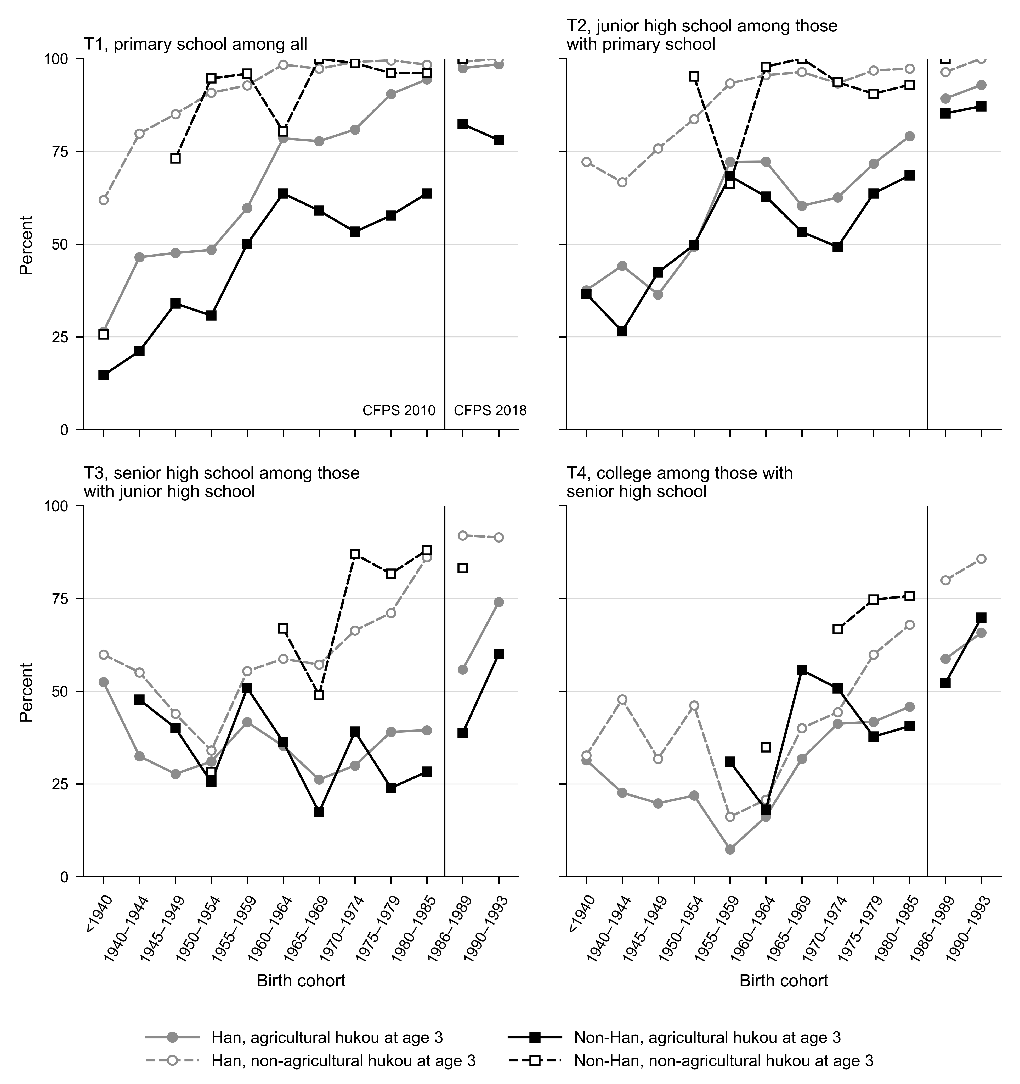
Note: Using CFPS 2010 and 2018 data. Percentages are weighted with the CFPS national cross-sectional weights of each wave. Cohorts born up to 1985 come from CFPS 2010 and cohorts born from 1986 to 1993 from CFPS 2018, so each line breaks where the source changes, at the vertical line.
Note: T1 is completing primary school among all respondents, T2 completing junior high school among those who completed primary school, T3 completing senior high school among those who completed junior high school and T4 completing college or above among those who completed senior high school. A point based on fewer than 10 respondents is not shown, which removes 5 of the 48 points of the non-Han group with agricultural hukou at age 3 and 19 of the 48 points of the non-Han group with non-agricultural hukou at age 3.

